**Lab_Day- 13 (Dictionary)**

1. Write a Python script to concatenate the following dictionaries to create a new one. Sample Dictionary : dic1={1:10, 2:20} dic2={3:30, 4:40} dic3={5:50,6:60} Expected Result : {1: 10, 2: 20, 3: 30, 4: 40, 5: 50, 6: 60}

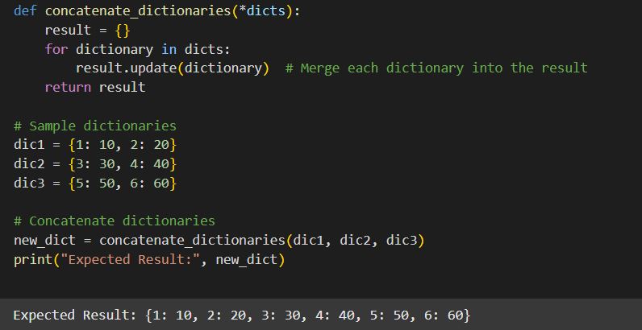

2. Write a Python program to get the key, value and item in a dictionary.

input: dict_num = {1: 10, 2: 20, 3: 30, 4: 40, 5: 50, 6: 60}

